Pulmonary Embolism location following splenectomy: a potential model for CTEPH development.

Darren White, MD (1). Kaan Raif, MD (2). Brian Locke, MD (1,3). Mark Dodson, MD (3).

1. University of Utah Division of Pulmonary, Critical Care, and Occupational Pulmonary Medicine

2. University of Utah Division of Internal Medicine

3. Intermountain Medical Center Department of Pulmonary and Critical Care

RATIONALE: Prior splenectomy may predispose patients to developing Chronic Thromboembolic Pulmonary Hypertension (CTEPH) after pulmonary embolism (PE). We have found that splenectomy is over-represented in CTEPH patients compared to patients with acute PE, suggesting that splenectomy increases risk of CTEPH beyond the risk that splenectomy confers on PE. We seek to understand how splenectomy modifies CTEPH risk. Acute PE patients with proximal thrombus and larger clot burden are more likely to develop CTEPH, however data from the European CTEPH Registry suggests CTEPH patients with splenectomy are more likely to be inoperable, indicating that splenectomy may predispose to more distal thromboembolic disease. In this study, we sought to characterize thrombus location and burden in acute PE patients with and without a history of splenectomy to determine how splenectomy modifies these characteristics.

METHODS: We performed a retrospective review of patients with splenectomy and PE compared against all comers with PE in Intermountain Hospitals. Two physicians independently analyzed the patient's CT angiography images from index PE. We quantified clot burden based on the Qanadli index and characterized PE as peripheral or central. Logistic regression (central vs peripheral) and Poisson (Qanadli index) regressions were used to evaluate for independent association between prior splenectomy and PE characteristics after accounting for age, gender and BMI.

RESULTS: 151 patients were included, 51 with splenectomy and 100 without splenectomy. For splenectomy vs no splenectomy 33% vs 48% were male (p 0.085), average BMI was 28.9 vs 31.1 (p 0.44), average age was 56(±16) vs 62(±15) (p 0.027). There was high inter-rater agreement between central vs. peripheral assessments (Kappa = 0.71), and excellent agreement in clot burden assessment (Kappa = 0.95 for Qanadli score). Patients with prior splenectomy had higher odds of peripheral PE than patients without splenectomy (odds ratio 2.97, 95% CI 1.24-7.15). There was no statistically significant difference in clot burden between the groups [Qanadli score 0.8 times as high in patients with splenectomy, 0.33-1.93].

CONCLUSIONS: Among patients with PE, splenectomy was independently associated with more peripheral clot location but no difference in clot burden. Our findings demonstrate that among acute PE patients, splenectomy contributes to an increased likelihood of distal vs. proximal clot. Further work will be necessary to determine how splenectomy modifies clot location. We hypothesize that splenectomy may modify thrombus structure, promoting development of distal clots that are more resistant to fibrinolysis, leading to the higher incidence of CTEPH observed among the splenectomy population.

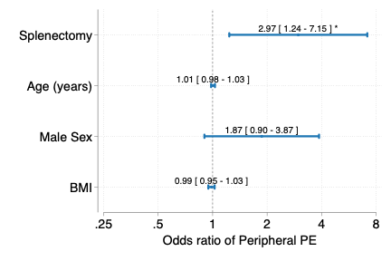

**Figure 1: Adjusted odds ratio of peripheral pulmonary embolism (PE), with 95% confidence intervals.**